Erasmus+ call 2025 – key messages
Please note that while the visuals shown below have EC branding, the uploaded versions feature EU branding.

General campaign message | Visual
Erasmus+ offers life-changing opportunities for individuals to learn, train, or volunteer across Europe, strengthening shared European values and supporting personal growth.  By focusing on education and skills development, Erasmus+ helps people build careers, understand each other better, and contributes to a stronger, more resilient Europe. | 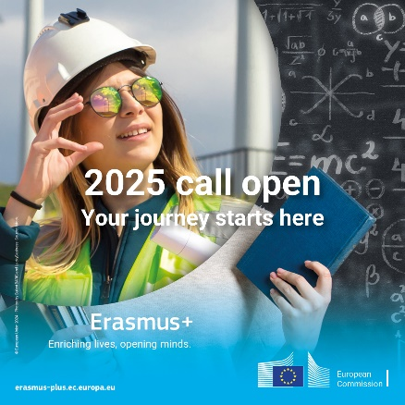

Sector-specific key messages

Erasmus+ goes beyond academic study but can also offer work placements / traineeships to help participants gain hands-on experience.  The programme can connect education with practical experience in keys sectors like green, digital and STEM. | 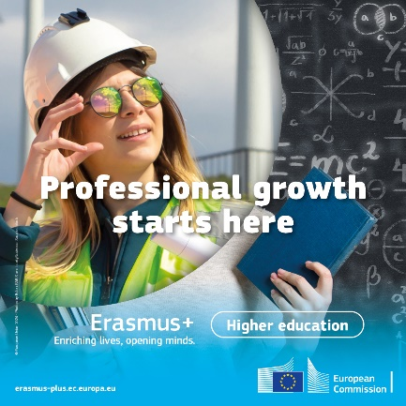
Erasmus+ plays a vital role in boosting vocational education, helping people gain the practical skills employers need.  Whether it is digital know-how or green job training, Erasmus+ ensures people are prepared for the future of work, making it a key player in Europe’s drive to support the green and digital transitions. | 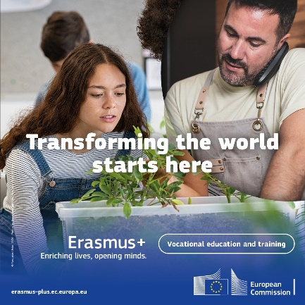
Erasmus+ supports lifelong learning, helping adult learners to keep improving their skills and adapt to the changing world of work.  Adult education as key sector for closing skills gaps and providing more people with access to quality training and education opportunities, including essential basic and literacy skills. | 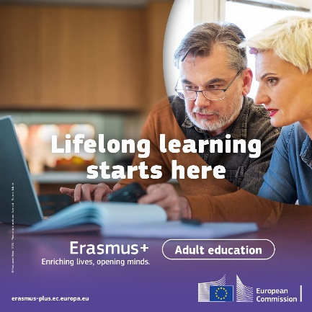
The programme offers mobility opportunities for pupils to equip them with the skills they need for tomorrow’s challenges.  Erasmus+ offers a range of opportunities teachers and other education staff to improve their knowledge, and skills.  Erasmus+ provides schools with the tools to cooperate with partners abroad, share best practices and become more open, dynamic and attractive. | 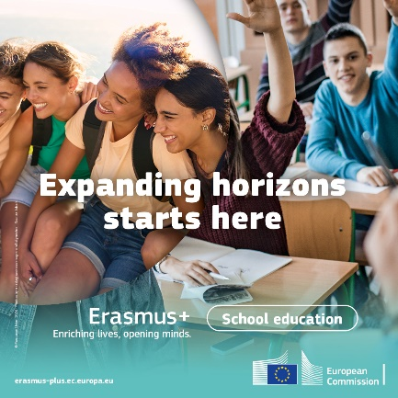
Erasmus+ empowers young people with the freedom and responsibility to engage meaningfully in their societies and democracies, providing opportunities to study, volunteer, and lead across Europe.  By fostering skills and shared experiences, Erasmus+ helps rebuild connections within communities and strengthen the European community. | 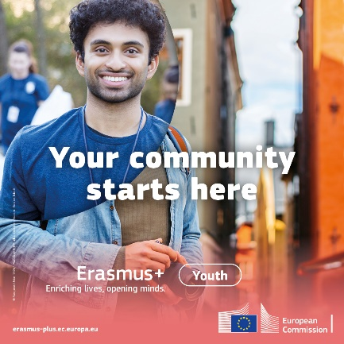
Erasmus+ activities in the field of sport promote participation in sport, physical activity, and voluntary initiatives, that are designed to tackle societal and sport-related challenges.  Designed for sports staff and professionals, the programme strengthens cross-border partnerships between organisations across Europe, enhancing learning, innovation, and skills in sports management. | 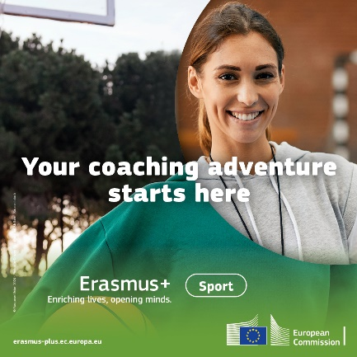

Priority-specific key messages

Supporting the green transition: Erasmus+ funds projects that promote eco-friendly practices and raise awareness, from reducing carbon footprints in mobility to supporting sustainable educational models. | 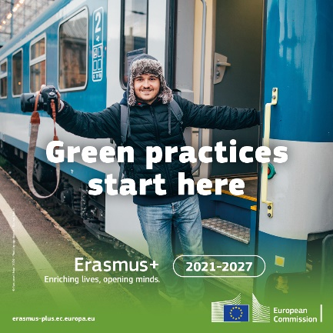
Erasmus+ plays a key role in ensuring that Europeans are equipped with the digital skills necessary to thrive in an increasingly tech-driven world.  The programme supports projects that promote digital literacy and innovation, ensuring no one is left behind in Europe’s digital transformation. | 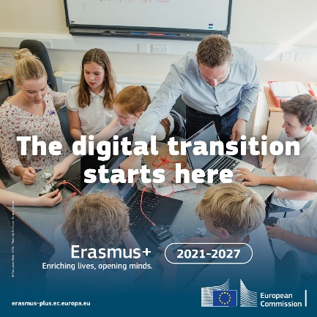
Erasmus+ fosters active citizenship by encouraging people to participate in projects that strengthen democracy, build social cohesion, and promote European values.  By giving citizens, especially young people, the tools to engage with their communities and the EU, Erasmus+ supports a more united and democratic Europe. | 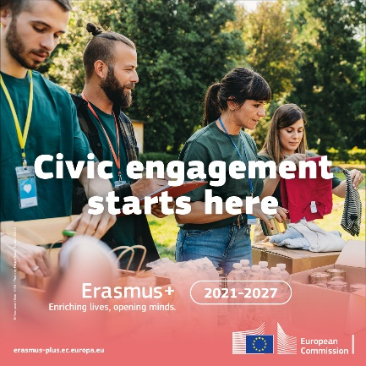
Erasmus+ has supported over 16 million mobilities since 1987 and continues to grow in popularity.  The programme is committed to improving access to Erasmus+ opportunities for individuals from all backgrounds.  Erasmus+ focuses on greater inclusion, ensuring equal access to opportunities, particularly for those with fewer opportunities. | 